

**Final Project Design Document**

### *V 1.0 –* GetPlaced

**Version 0.1**

**Document Change History**

|  |  |  |  |
| --- | --- | --- | --- |
| **Version** | **Date** | **Author** | **Comments** |
| 1.0 | 28/05/2016 | Sahil Arora | First draft |

**Overview of Application**

5 new things a user can know about the company coming to their college –

1. List of Upcoming Companies

2. List of companies based on selected month

3. Eligibility Criteria for the company

4. Company's Prerequisites

5. KnowHow of the company( includes web page links)

6. Alumini Reviews for the Company

**Overview of Design**

1. The title page.
2. User can click on the “Get Placed” button and switch to the Login Screen.

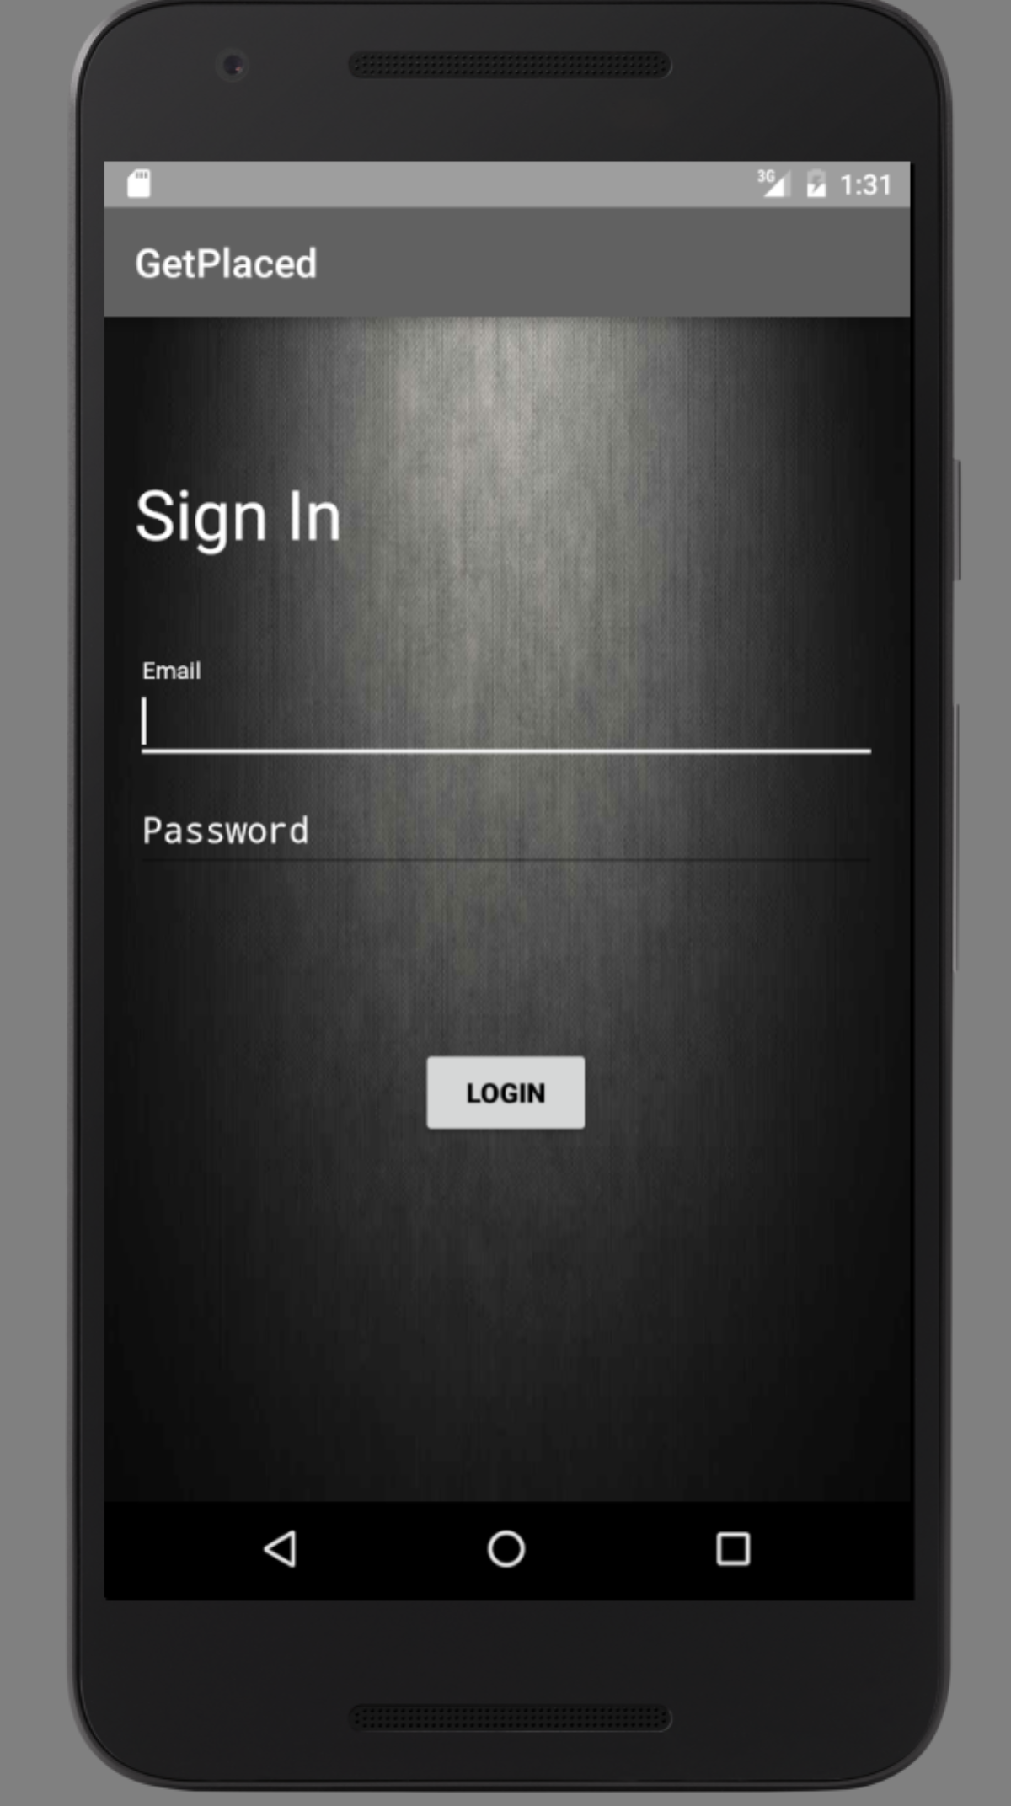

1. Or, User can wait for 5 seconds, and the app will automatically be redirected to the Login Page.
2. Enter the credentials –
   1. Username – admin
   2. Password – admin

Click on the Login Button, and the User is redirected to Upcoming Companies activity.

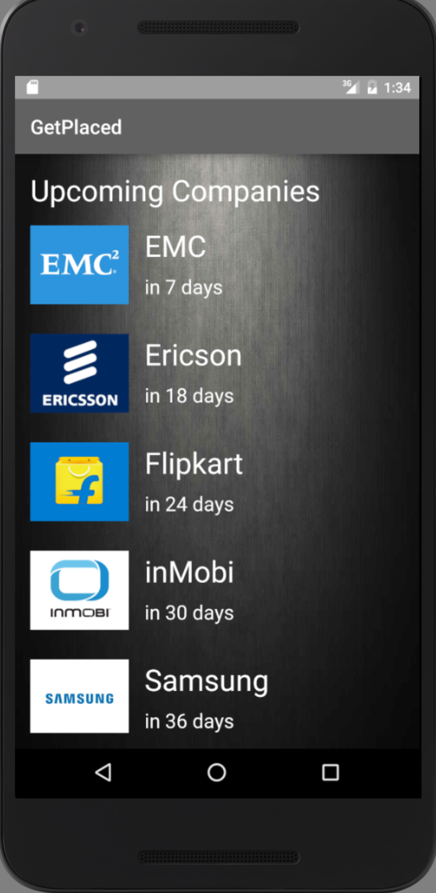

1. Select any company, and the User is directed to the Activity showing details of the company.

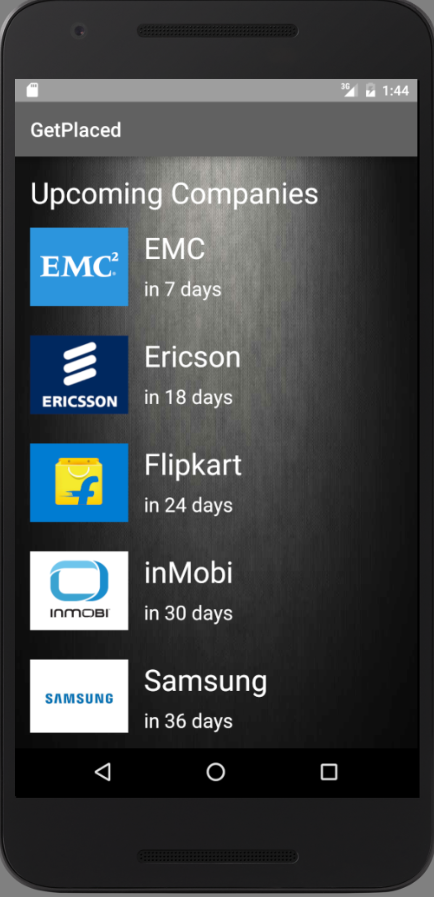

1. Click the “Sort By Calendar” button, and select June/July.

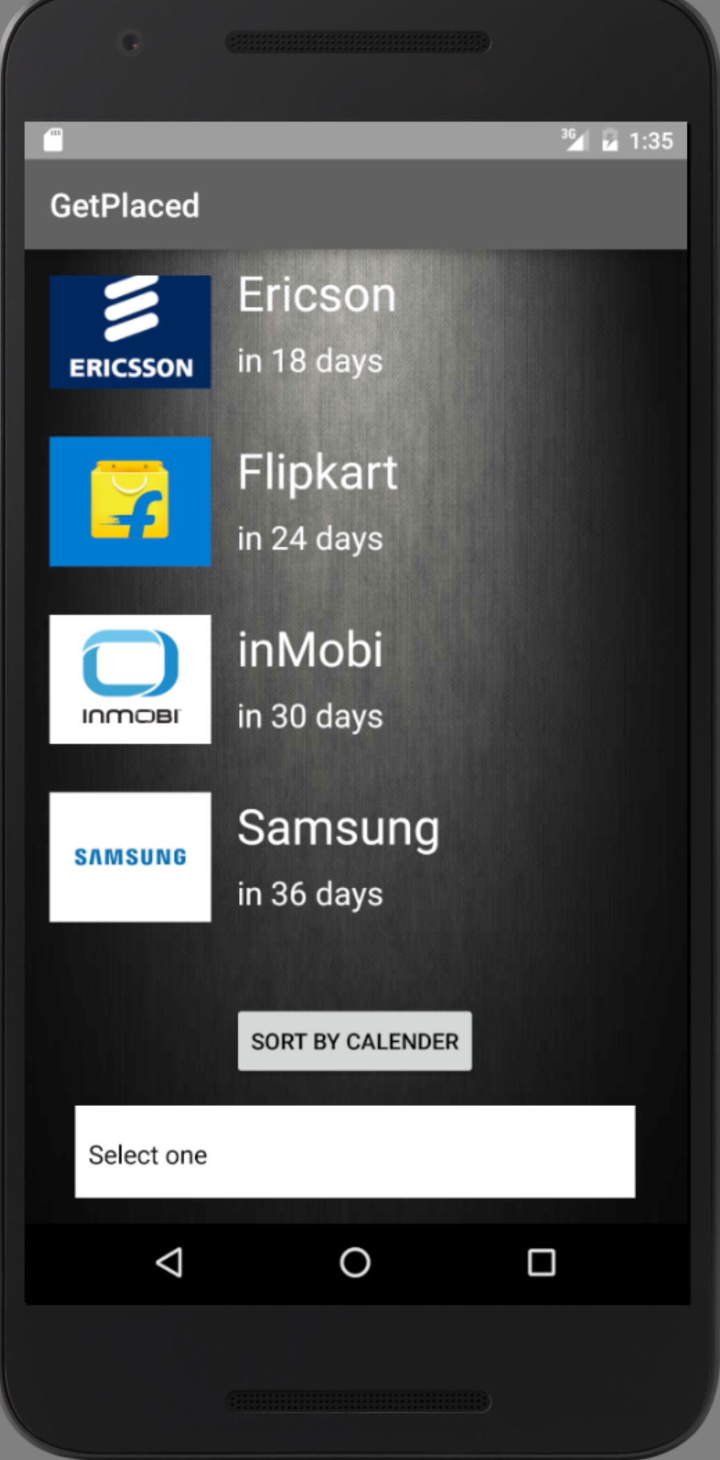

1. A list of companies for that particular month are displayed to the user.

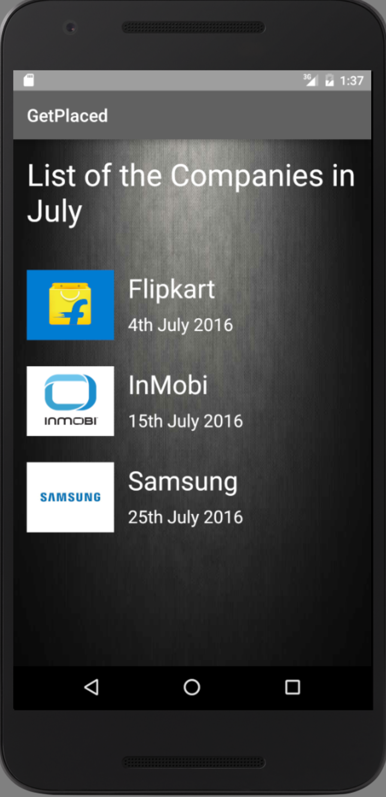

1. Click on any company and the User is directed to the Activity showing details of the company.

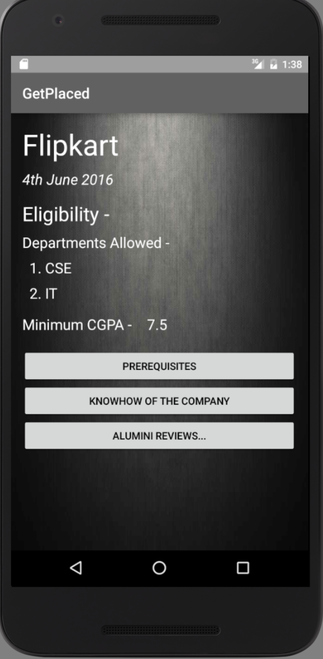

1. Click the “Prerequisites” button, and user is directed to the prerequisites activity for that particular company.

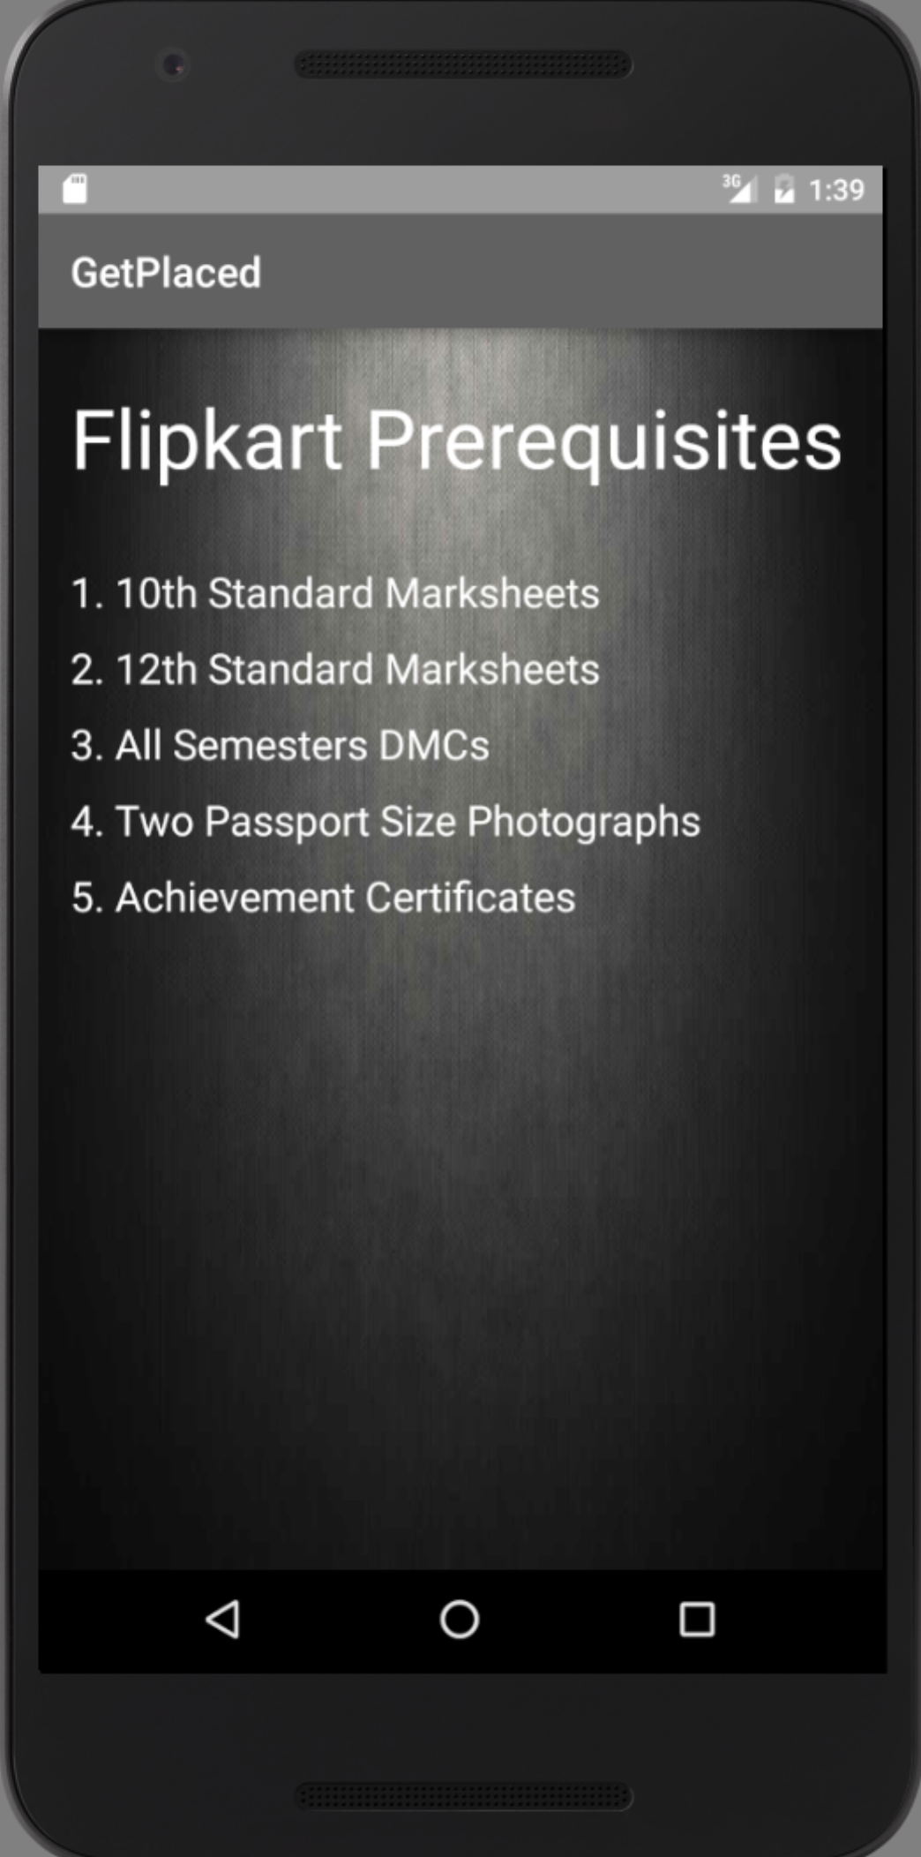

1. Click the “KnowHow “button, and user is directed to the prerequisites activity for that particular company.

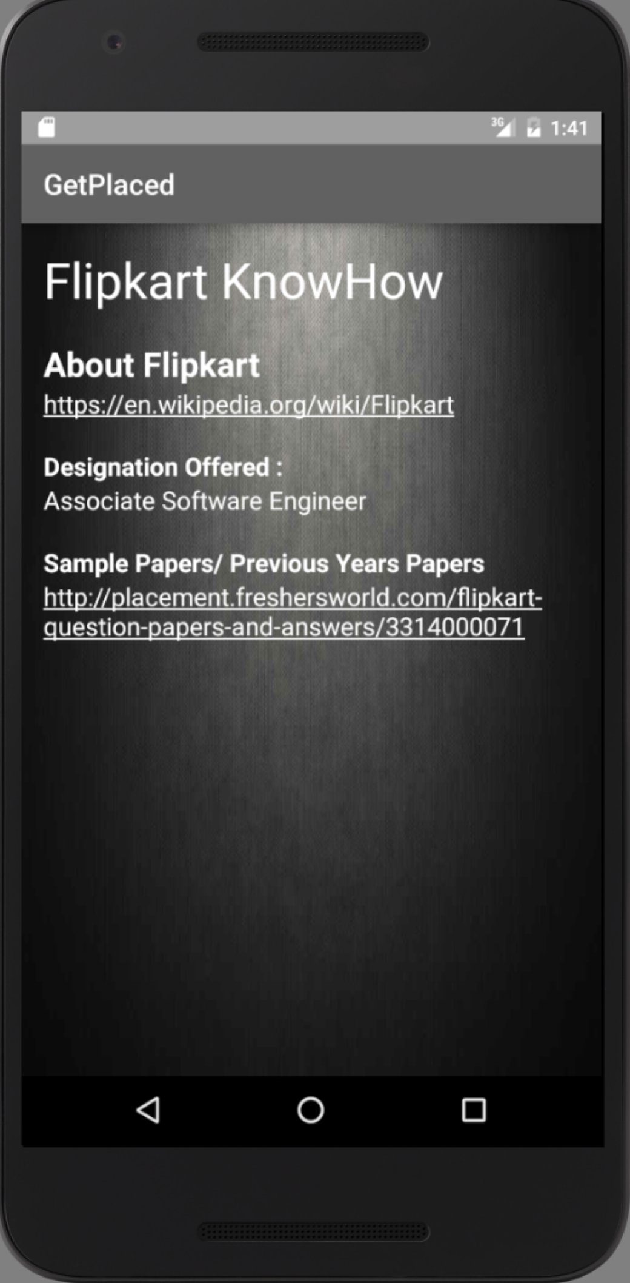

1. Click on the link and the user is directed to the web page link.
2. Click on the “Alumini Reviews Button”, and user is displayed the list of the aluminis and their reviews for that company.

